

DATA DRIVEN DECISION MAKING

REPORT ON

A Data-Driven Approach to Improving Efficiency in Hospital Observation Units

REPORT BY
SRI NIKITA DESETTY
TRILOK DHANEKULA
SAI SIVA DEEKSHITA CHITHAJHALLU

CONTENTS

Contents
1.Executive Summary: 3
2. Problem Description: 3
3. Exploratory Data Analysis 3
3.1 Data Cleaning and Pre-Processing 3
3.2 Data Partitioning 4
3.3 Variable Selection 4
4. Methodology 5
4.1 Data Visualization 5
4.2Modeling 5
4.3 Performance Criteria 6
5. Results 6
5.1 Model Outcomes 6
5.2 Analysis of Findings 7
5.3 Assumptions Considered 7
6. Recommendations 7
6.1 Update Admission Criteria 7
6.2 Monitor Performance Continuously 8
6.3 Expected Outcomes 8
7.Appendix 8

1.Executive Summary:
  - Montanaro Hospital’s Observation Unit (HOU) faces problems with patients staying longer than expected and often needing to be moved to inpatient care, which reduces available beds and causes delays in the Emergency Department. To address this, we analyzed patient information, including age, health measurements, and diagnoses, using models to identify patterns in which patients were most likely to need inpatient care. Our results showed that factors like breathing rate, oxygen levels, and length of stay could help predict these needs. We recommend updating HOU admission guidelines to prioritize patients less likely to need inpatient care, which would free up beds, improve patient flow, and reduce delays in the hospital.

2. Problem Description:
Montanaro Hospital’s Observation Unit (HOU) is intended for short-term care but faces challenges with patients staying longer than expected and often needing to move to inpatient care. These frequent, unplanned transfers reduce available beds in the HOU, which creates delays for patients in the Emergency Department waiting for open spaces. This situation leads to overcrowding, increases pressure on hospital resources, and slows down overall patient care. To solve this, the hospital needs a data-driven approach to identify which patients are likely to require inpatient care, allowing them to adjust admission guidelines, improve patient flow, and make better use of resources.

3. Exploratory Data Analysis
This section outlines the initial data exploration and preparation steps taken to ensure the data quality and suitability for predictive modeling. It covers data cleaning, partitioning, and variable selection, all aimed at identifying patterns that may predict the likelihood of patients transitioning to inpatient care

3.1 Data Cleaning and Pre-Processing
The initial dataset contained various patient information, including demographic details, health metrics, and diagnostic codes. To prepare the data for analysis:
- Handling Missing Values Missing values in numeric columns were addressed using mean imputation. Rather than removing rows, missing entries were replaced with the mean of each column, ensuring data completeness and preserving important health metrics for reliable predictions.
- Data Type Conversion: Health metrics such as blood pressure, pulse, and respiration rate were converted to numeric data types to facilitate analysis and model training.
- Categorical Variables: Diagnosis codes (DRG01) were converted into labeled categories, making the data more interpretable. For example, diagnostic codes were labeled as conditions like "Congestive Heart Failure," "Chest Pain," and "Pneumonia."
- Outlier Handling: We used the Interquartile Range (IQR) method to remove extreme values, especially in metrics with high variability like pulse and respirations, resulting in a cleaner and more reliable dataset for analysis.

3.2 Data Partitioning
To develop and validate predictive models effectively, the dataset was divided as follows:
- Training and Validation Sets: The data was split into 70% for training and 30% for validation. This approach allowed the model to learn from most data while maintaining an independent set for unbiased evaluation.
- Stratified Sampling: A stratified approach was used to ensure both the training and validation sets were representative of the overall distribution, particularly for the target variable, “flipped” status.

3.3 Variable Selection
For predictive modeling, selecting the most relevant variables was crucial to improve model performance and interpretability:
- Initial Screening: An exploratory analysis using visualizations like boxplots and correlation heatmaps helped identify potential predictors of inpatient transitions.
- Stepwise Selection: Using stepwise selection, the final variables included in the model were BloodPressureLower, Temperature, OU_LOS_hrs, and diagnostic category (DRG01). These variables were selected based on statistical significance and relevance to patient outcomes, contributing to a robust predictive model.

3.4 One-Way ANOVA Analysis
To examine factors affecting length of stay in the observation unit, one-way ANOVA analyses were conducted on diagnostic category (DRG01) and age group.
- Diagnostic Categories (DRG01): The ANOVA revealed significant differences in length of stay across diagnostic categories (p < 0.001).
  - Tukey’s HSD Test: Pairwise comparisons showed that patients with urinary tract infections had significantly longer stays than those with dehydration, while patients with chest pain had shorter stays compared to those with urinary tract infections.
- Age Groups: A significant effect of age group on length of stay was observed (p < 0.001).
  - Tukey’s HSD Test: Tukey’s test revealed that elderly patients generally had longer stays than adults, young adults, and seniors.

4. Methodology
This section provides a comprehensive overview of the methodology used to analyze the data and predict inpatient transitions within Montanaro Hospital’s Observation Unit (HOU). The methodology consists of data visualization, data processing, model selection, and evaluation metrics to address the challenges identified.

4.1 Data Visualization
The initial exploratory data analysis included various visualizations to better understand relationships within the dataset and guide variable selection:
- Correlation Heatmap: A correlation heatmap was generated to explore relationships between health metrics and the target variable, “flipped” status. It highlighted moderate correlations, such as between respiration rate and the likelihood of inpatient transition, providing early insights into predictive features.
- Boxplots: Boxplots were used to compare health metrics, like blood pressure and respiration rate, across patient groups (flipped vs. non-flipped). These visualizations helped identify differences in health metrics associated with higher inpatient transition likelihood.
- Scatterplots: Scatterplots plotted age against length of stay, revealing trends that patients with extended stays were more likely to transition to inpatient care. These insights were useful for subsequent model building.

4.2Modeling
To predict the likelihood of inpatient transitions, two modeling techniques were applied:
- Logistic Regression:
  - Purpose: Logistic regression was selected as a baseline model due to its interpretability and effectiveness in binary classification.
  - Implementation: The model included key predictors identified in the EDA, such as respiration rate, pulse oximetry, and length of stay.
  - Results: Logistic regression provided insights into the relationship between each predictor and the likelihood of inpatient transitions, with significant predictors like respiration rate indicating increased odds of a flip.
- Random Forest:
  - Purpose: Random Forest was chosen for its ability to handle non-linear relationships and interactions between predictors, making it suitable for complex medical data.
  - Implementation: The model was trained using selected predictors, including age, respiration rate, pulse oximetry, diagnosis category, and length of stay.
  - Results: Random Forest showed stronger predictive performance than logistic regression, especially in capturing complex interactions, making it a preferred model for this analysis.

4.3 Performance Criteria
Each model’s performance was evaluated using key metrics:
- Accuracy: The Logistic Regression model achieved an accuracy of 77.02%, while the Random Forest model achieved 75.81%. Both models performed above the baseline, correctly classifying approximately three-quarters of the observations.
- AUC (Area Under the Curve): The AUC score, which assesses the model's ability to distinguish between observation and inpatient needs, was 0.82 for Logistic Regression and slightly lower for Random Forest. This suggests that both models performed well, with Logistic Regression having a slight edge in distinguishing between the two classes.
- Sensitivity and Specificity: Sensitivity measures the models' ability to correctly identify patients who needed inpatient care, while specificity reflects their accuracy in identifying those who did not. The Logistic Regression model showed higher sensitivity at 80.27% but a lower specificity of 72.28%, which resulted in a higher rate of false positives. The Random Forest model, on the other hand, had a more balanced sensitivity of 74.26% and specificity of 76.87%, offering a more even classification performance.
- Confusion Matrix: The confusion matrix for each model highlighted areas of misclassification. The Logistic Regression model performed well in identifying true positives, while the Random Forest model provided a more balanced error distribution, which may make it more suitable for applications where balanced classification is preferred

5. Results
The analysis focused on developing models to predict which patients in Montanaro Hospital’s Observation Unit (HOU) would likely need inpatient care. Two models were utilized: Logistic Regression and Random Forest.

5.1 Model Outcomes
- Logistic Regression Model:
  - Accuracy: The model achieved an accuracy of 74.6%, which is above the baseline (59.27%).
  - Sensitivity: Sensitivity was 78.91%, indicating a good ability to identify patients needing inpatient care.
  - Specificity: The Specificity was 68.32%, showing moderate accuracy in identifying those not needing inpatient care.
  - Balanced Accuracy: The balanced accuracy was 73.61%, showing a fair balance between sensitivity and specificity.
  - ROC Curve and AUC: The model’s ROC curve (see figure) had an Area Under the Curve (AUC) of 0.82, reflecting strong discriminatory power in distinguishing between classes.

- Random Forest Model:
  - Accuracy: The model achieved an accuracy of 75%, surpassing the baseline of 59.27%.
  - Sensitivity and Specificity: Sensitivity was 73.27%, indicating moderate ability to correctly identify patients who needed inpatient care. Specificity was 76.19%, reflecting good accuracy in identifying those who did not need inpatient care.
  - Balanced Accuracy: The balanced accuracy was 74.73%, showing an even performance in predicting both patient groups.
  - ROC Curve and AUC: The model's ROC curve (see figure) illustrates its classification effectiveness, with an Area Under the Curve (AUC) indicative of strong discriminatory ability.

5.2 Analysis of Findings
The analysis revealed key predictors like respiration rate and length of stay that significantly impact patient transitions to inpatient care. The Logistic Regression model performed well in detecting patients needing care, while the Random Forest model provided a balanced approach, making it useful for clinical applications.

5.3 Assumptions Considered
Several assumptions were made during the analysis:
- The dataset was assumed to be representative after removing missing values.
- Selected predictors were deemed relevant based on exploratory analysis.
- Each patient visit was treated as independent, and class distribution was maintained to avoid biases.

6. Recommendations
Based on the analysis, the following actions are recommended to improve patient management in Montanaro Hospital’s Observation Unit (HOU):

6.1 Update Admission Criteria
- Revise Guidelines: Change the admission rules to focus on patients who are less likely to need inpatient care, using important factors like breathing rate and length of stay.
- Staff Training: Educate staff on how to use the predictive model results to make better decisions about who to admit.

6.2 Monitor Performance Continuously
- Tracking System: Set up a system to monitor key metrics, such as patient transitions and how long patients stay, to evaluate the effectiveness of the new admission criteria.
- Regular Updates: Continuously gather new patient data and update the predictive models to ensure they remain accurate and relevant.

6.3 Expected Outcomes
- Better Patient Flow: Improving admission criteria will lead to more available beds in the OU and reduce crowding in the Emergency Department.
- Efficient Use of Resources: This will help the hospital use its resources better, resulting in cost savings and improved care for patients.
- Improved Patient Care: A focus on data-driven practices will lead to better health outcomes for patients.

7.Appendix:
Fig 1 – Correlation Heatmap of Numeric Variables
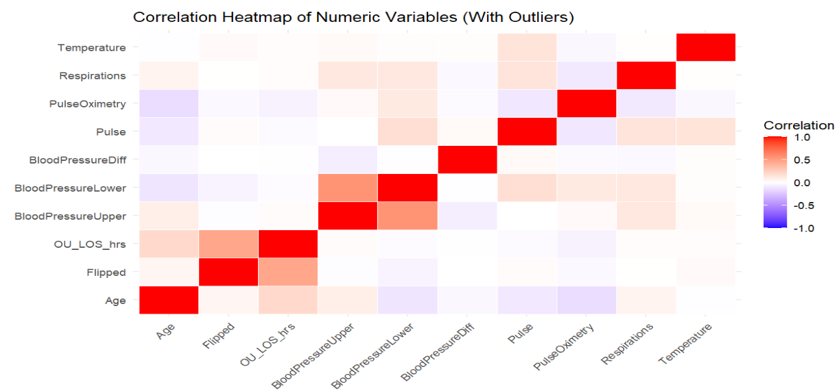
The correlation heatmap illustrates relationships between numeric variables, with color intensity indicating correlation strength and direction. Key findings include strong positive correlations between BloodPressureUpper and BloodPressureLower, as well as Temperature and Respirations. Additionally, moderate correlations were observed between Age and OU_LOS_hrs, as well as Flipped status and OU_LOS_hrs, suggesting that certain health metrics may influence observation unit length of stay and patient outcomes.
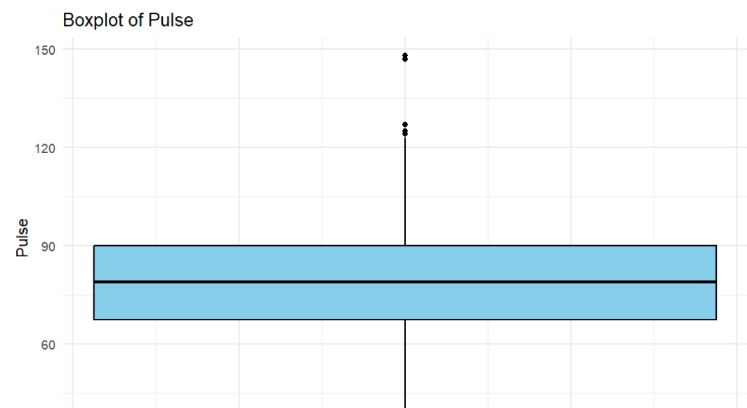
Fig 2 – Boxplot of pulse

Fig 3 - Boxplot of Blood pressure difference
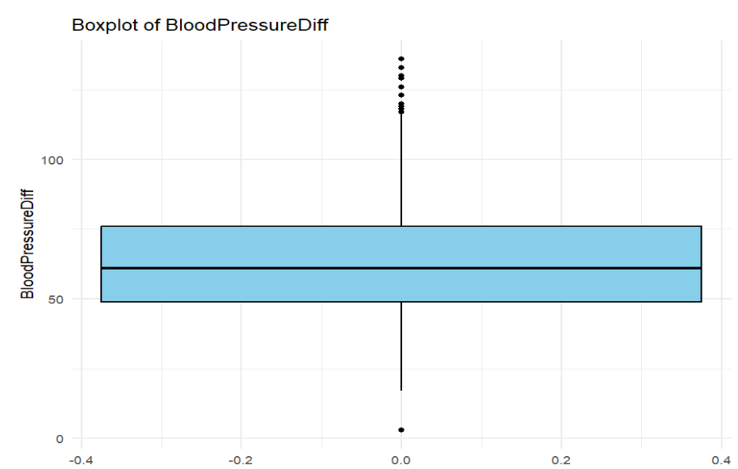

Fig 4 - Boxplot of Blood pressure lower
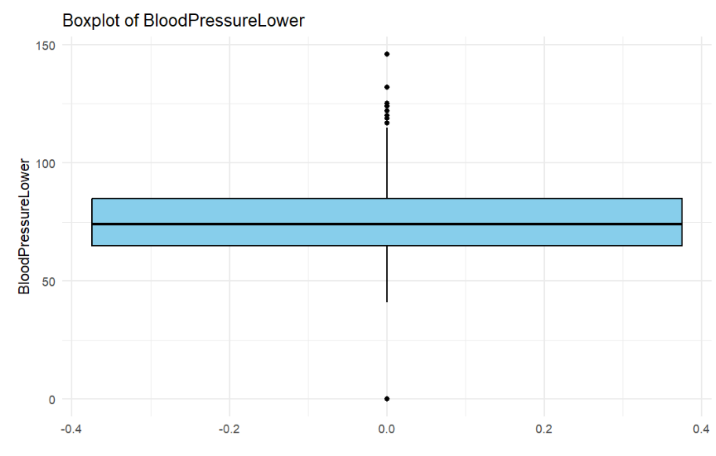

Fig 5 – Boxplot of Temperature
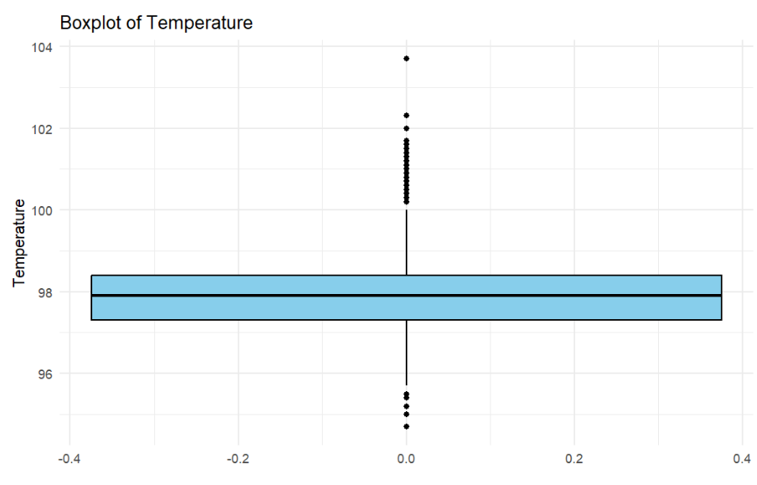

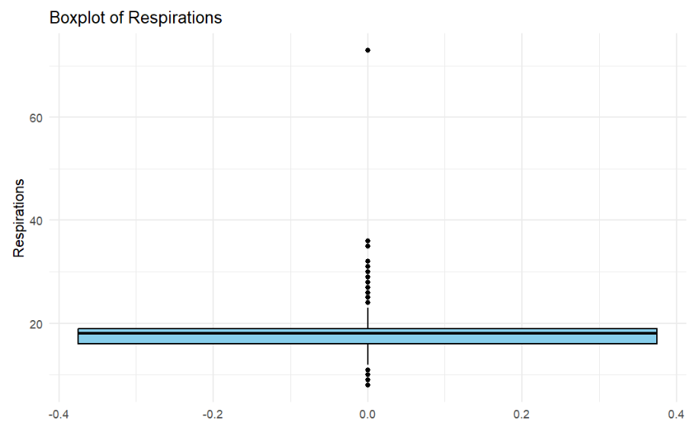
Fig 6 – Boxplot of Respirations

Fig 7 - Boxplot of Length of stay
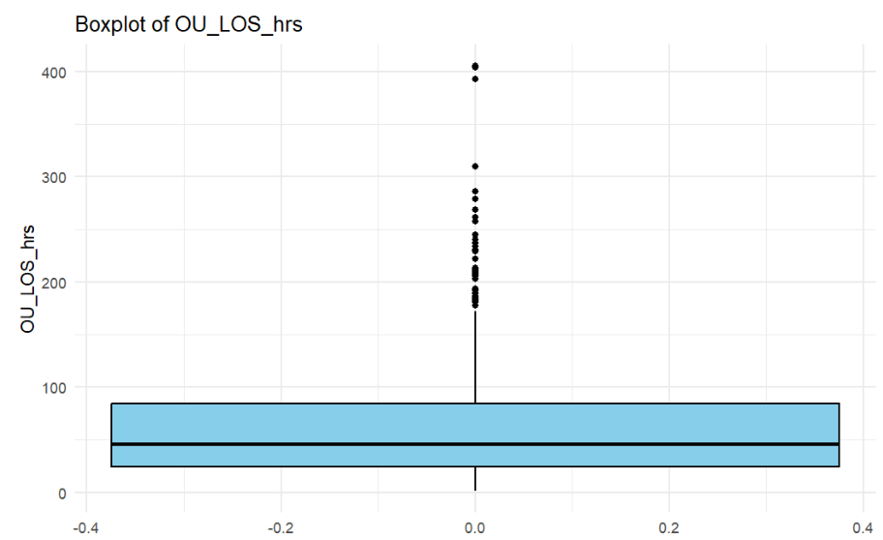

Fig 8 - Histogram of Pulse
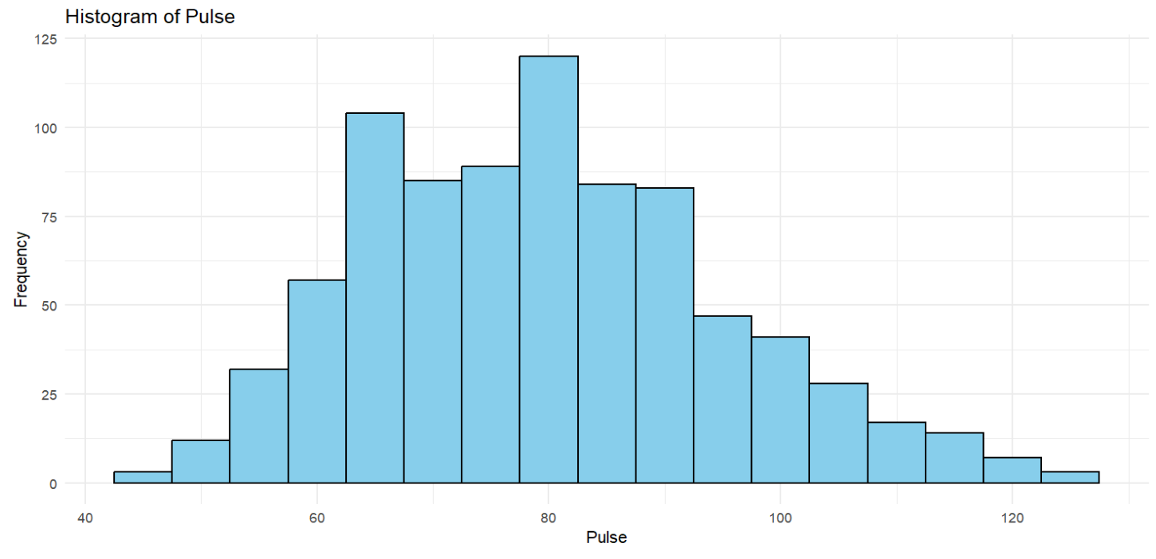

Fig 9 – Heatmap of Age VS Length of stay
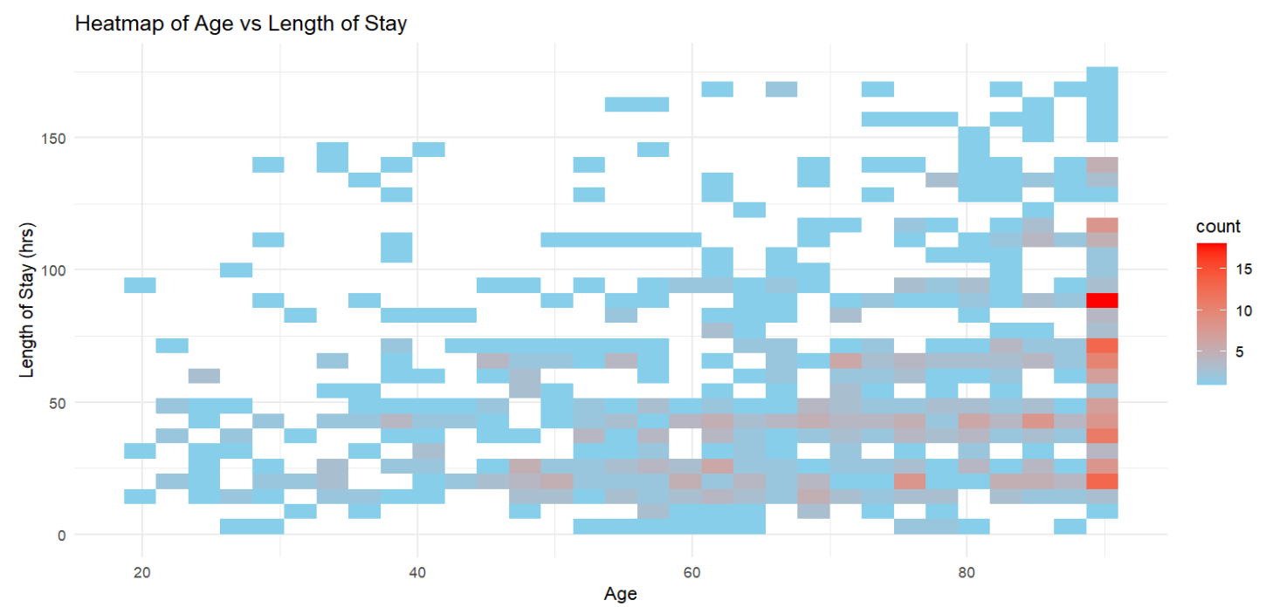

Fig 10 – Pulse vs Length of stay by Diagnosis
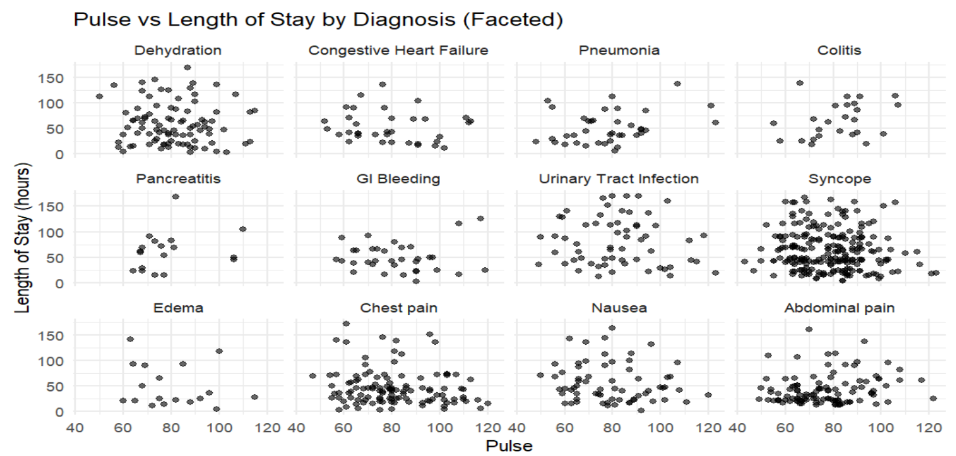

Fig 11- Boxplot of Length of stay by Age Group
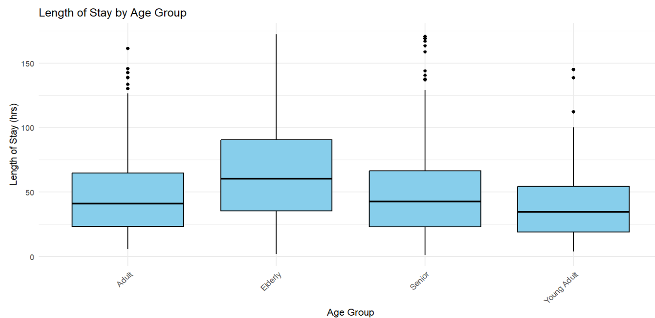

Fig 12- Roc for Logistic Regression
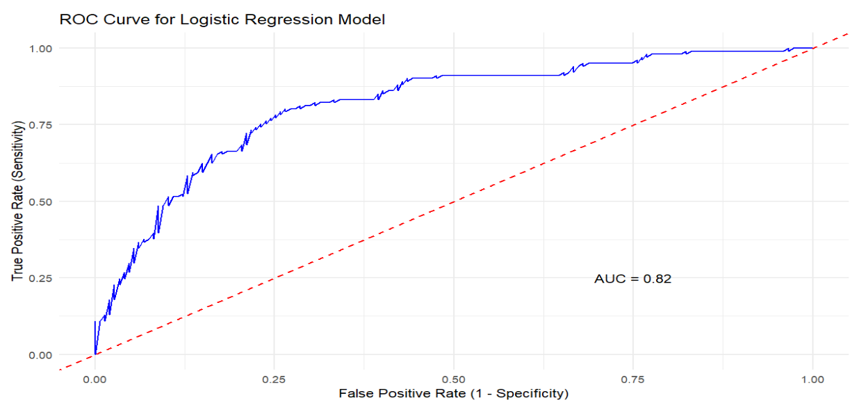

Fig 13 – ROC for Random Forest
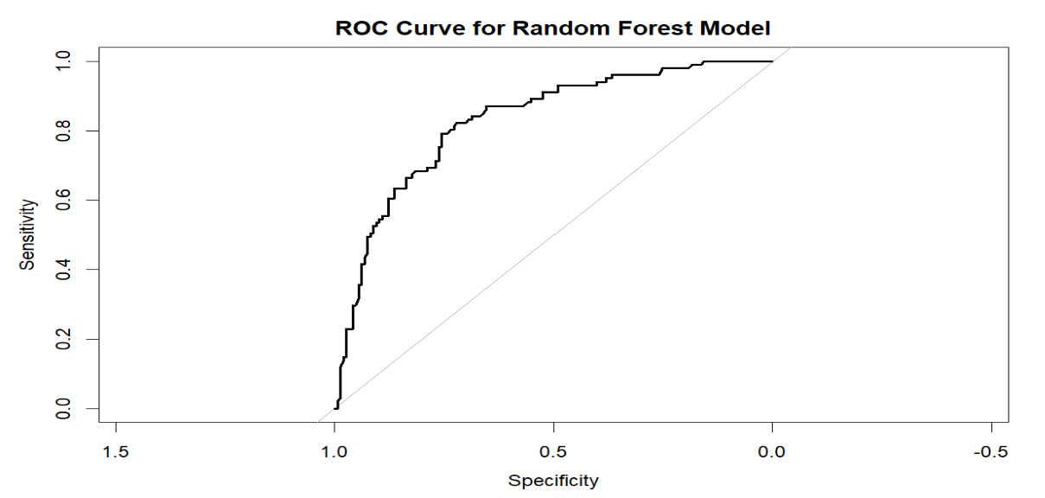

Fig 14 – Random Forest results
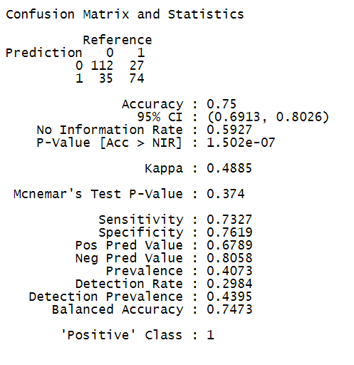

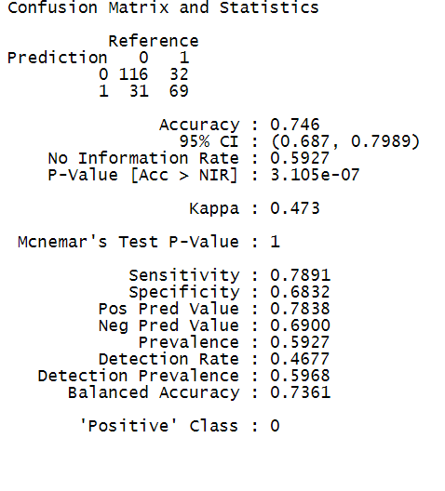
Fig 15 – Logistic Regression Results

Fig 16 - Random Forest
